Percival H. - Architecture Patterns with Python
- Software systems, too, tend toward chaos. Over time we find that it gathers cruft and edge cases and ends up a confusing morass of manager classes and util modules.
- Fortunately, the techniques to avoid creating a big ball of mud aren't complex:
  - Encapsulation and Abstractions
The term encapsulation covers two closely related ideas:
simplifying behavior and hiding data. In this discussion, we’re
using the first sense.
We encapsulate behavior by identifying a task
that needs to be done in our code and giving that task to a well-defined object or function. We call that object or function an
abstraction.
  - Layering
When one function, module, or object uses another, we say that the one depends on the other.
In a layered architecture, we divide our code into discrete categories or roles, and we introduce rules about which categories of code can call each other.
  - The Dependency Inversion Principle
High-level modules are the code that your organization really cares about. Low-level modules are the code that your organization doesn’t care about.
So the first part of the DIP says that our business code shouldn’t depend on technical details; instead, both should use abstractions. Why? Broadly, because we want to be able to change them independently of each other.
The second part is even more mysterious. “Abstractions should not
depend on details” we’ll have a concrete example in Chapter 4.
  - A Place for All Our Business Logic: The Domain Model
One of the most common reasons that
our designs go wrong is that business logic becomes spread
throughout the layers of our application, making it hard to identify,
understand, and change.

Part I. Building an Architecture to Support Domain Modeling
Notes
- Behavior should come first and drive our storage requirements. After all, our customers don’t care about the data model. They care about what the system does; otherwise they’d just use a spreadsheet.
- To create stable APIs around our domain we present four key design patterns:
  - The Repository pattern, an abstraction over the idea of persistent storage
  - The Service Layer pattern to clearly define where our use cases begin and end
  - The Unit of Work pattern to provide atomic operations
  - The Aggregate pattern to enforce the integrity of our data
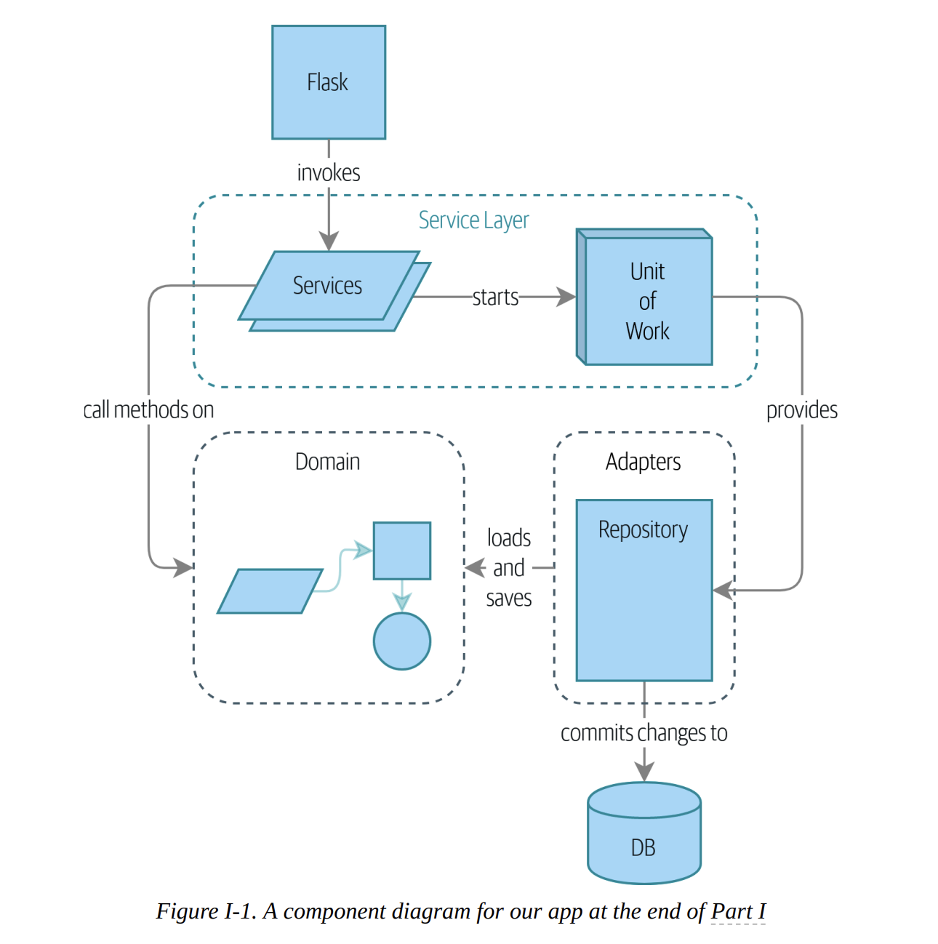

- The domain is a fancy way of saying the problem you’re trying to solve.
A model is a map of a process or phenomenon that captures a useful property.
The domain model is the mental map that business owners have of their businesses.
- When we hear our business stakeholders using unfamiliar words, or using terms in a specific way, we should listen to understand the deeper meaning and encode their hard-won experience into our software.
- We have an initial conversation with our business experts and agree on a glossary and some rules for the first minimal version of the domain model. Wherever possible, we ask for concrete examples to illustrate each rule. We make sure to express those rules in the business jargon (the ubiquitous language in DDD terminology). We choose memorable identifiers for our objects so that the examples are easier to talk about.
- Whenever we have a business concept that has data but no identity, we often choose to represent it using the Value Object pattern. A value object is any domain object that is uniquely identified by the data it holds; we usually make them immutable.
- One of the nice things that dataclasses (or namedtuples) give us is value equality, which is the fancy way of saying, “Two lines with the same orderid, sku, and qty are equal.”
- Entities, unlike values, have identity equality. We can change their values, and they are still recognizably the same thing. Batches, in our example, are entities. We can allocate lines to a batch, or change the date that we expect it to arrive, and it will still be the same entity.
- Python’s __eq__ magic method defines the behavior of the class for the == operator.
For both entity and value objects, it’s also worth thinking through how __hash__ will work. It’s the magic method Python uses to control the behavior of objects when you add them to sets or use them as dict keys.
- You shouldn’t modify __hash__ without also modifying __eq__.
- Magic methods can express domain semantics (e.g. __gt__).
- Exceptions can express domain concepts too.
- Recap:
  - Domain modeling: This is the part of your code that is closest to the business, the most likely to change, and the place where you deliver the most value to the business. Make it easy to understand and modify.
  - Distinguish entities from value objects: A value object is defined by its attributes. It’s usually best implemented as an immutable type. If you change an attribute on a Value Object, it represents a different object. In contrast, an entity has attributes that may vary over time and it will still be the same entity. It’s important to define what does uniquely identify an entity (usually some sort of name or reference field).
  - Not everything has to be an object: Python is a multiparadigm language, so let the “verbs” in your code be functions. For every FooManager, BarBuilder, or BazFactory, there’s often a more expressive and readable manage_foo(), build_bar(), or get_baz() waiting to happen.
  - This is the time to apply your best OO design principles: Revisit the SOLID principles and all the other good heuristics like “has a versus is-a,” “prefer composition over inheritance,” and so on.
- But we want our domain model to have no dependencies whatsoever. We don’t want infrastructure concerns bleeding over into our domain model and slowing our unit tests or our ability to make changes.
- We’ll think of our model as being on the “inside,” and dependencies flowing inward to it; this is what people sometimes call onion architecture. (Presentation Layer -> Domain Model <- Database Layer).
- These days, it’s unlikely that your team members are hand-rolling their own SQL queries. Instead, you’re almost certainly using some kind of framework to generate SQL for you based on your model objects.
These frameworks are called object-relational mappers (ORMs) because they exist to bridge the conceptual gap between the world of objects and domain modeling and the world of databases and relational algebra.
The most important thing an ORM gives us is persistence ignorance: the idea that our fancy domain model doesn’t need to know anything about how data is loaded or persisted. This helps keep our domain clean of direct dependencies on particular database technologies.
- The alternative is to define your schema separately, and to define an explicit mapper for how to convert between the schema and our domain model.
- The Repository pattern is an abstraction over persistent storage. It hides the boring details of data access by pretending that all of our data is in memory.
- The simplest repository has just two methods: add() to put a new item in the repository, and get() to return a previously added item.
- In real life, we’ve sometimes found ourselves deleting ABCs from our production code, because Python makes it too easy to ignore them, and they end up unmaintained and, at worst, misleading. In practice we often just rely on Python’s duck typing to enable abstractions. To a Pythonista, a repository is any object that has add(thing) and get(id) methods.
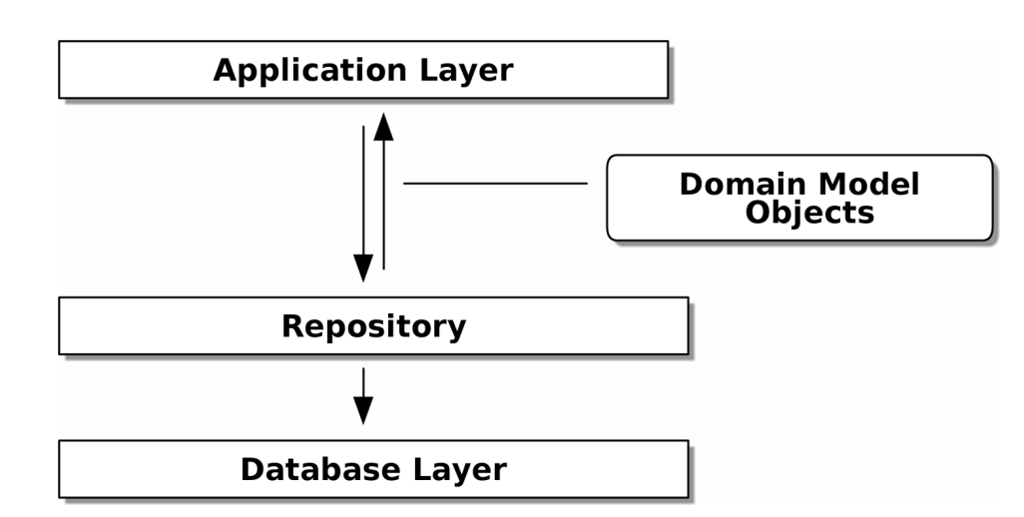
- Building a fake Repository for tests Is now trivial!
- Building fakes for your abstractions is an excellent way to get design feedback: if it’s hard to fake, the abstraction is probably too complicated.
- Repository pattern and persistence ignorance: the trade-offs.
Pros
  - We have a simple interface between persistent storage and our domain model.
  - It’s easy to make a fake version of the repository for unit testing, or to swap out different storage solutions, because we’ve fully decoupled the model from infrastructure concerns.
  - Writing the domain model before thinking about persistence helps us focus on the business problem at hand. If we ever want to radically change our approach, we can do that in our model, without needing to worry about foreign keys or migrations until later.
  - Our database schema is really simple because we have complete control over how we map our objects to tables.
Cons:
  - An ORM already buys you some decoupling. Changing foreign keys might be hard, but it should be pretty easy to swap between MySQL and Postgres if you ever need to.
  - Maintaining ORM mappings by hand requires extra work and extra code.
  - Any extra layer of indirection always increases maintenance costs and adds a “WTF factor” for Python programmers who’ve never seen the Repository pattern before.
- If your app is just a simple CRUD (create-read-update-delete) wrapper around a database, then you don’t need a domain model or a repository.
But the more complex the domain, the more an investment in freeing yourself from infrastructure concerns will pay off in terms of the ease of making changes.
- Repository Pattern Recap
Apply dependency inversion to your ORM
  - Our domain model should be free of infrastructure concerns, so your ORM should import your model, and not the other way around.
The Repository pattern is a simple abstraction around permanent storage
  - The repository gives you the illusion of a collection of in-memory objects. It makes it easy to create a FakeRepository for testing and to swap fundamental details of your infrastructure without disrupting your core application.
- A key theme in this book, hidden among the fancy patterns, is that we can use simple abstractions to hide messy details.
- When we’re unable to change component A for fear of breaking component B, we say that the components have become coupled.
- Locally, coupling is a good thing: it’s a sign that our code is working together, each component supporting the others, all of them fitting in place like the gears of a watch. In jargon, we say this works when there is high cohesion between the coupled elements. Globally, coupling is a nuisance: it increases the risk and the cost of changing our code, sometimes to the point where we feel unable to make any changes at all.
- We can reduce the degree of coupling within a system by abstracting away the details.
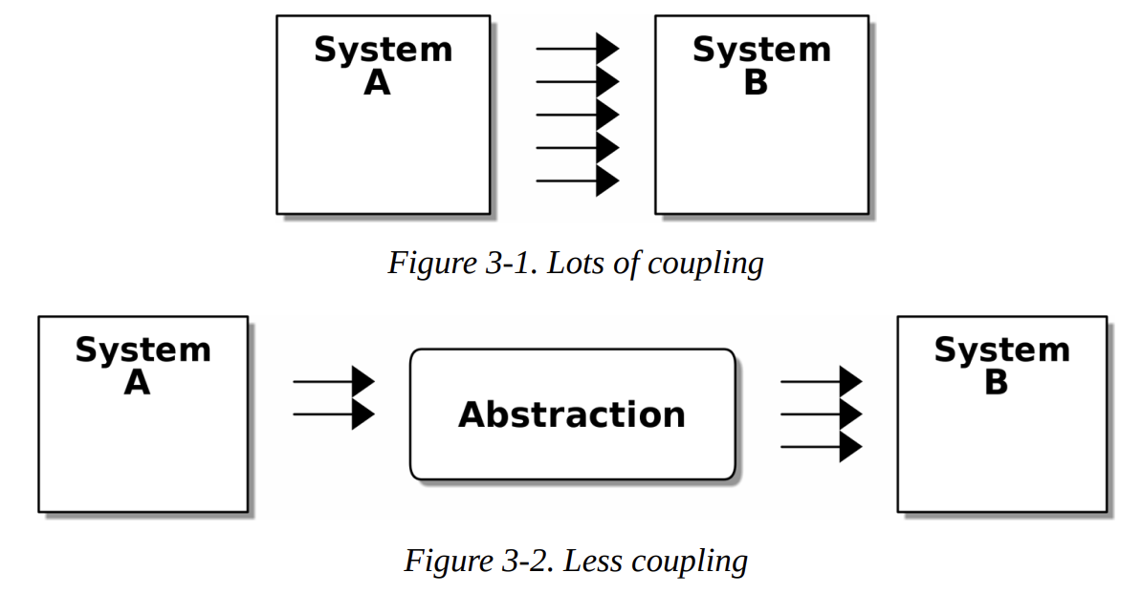
- [To create the right abstraction] We’ll apply a trick here that we’ll employ on a grand scale later in the book. We’re going to separate what we want to do from how to do it.
- Our goal is to isolate the clever part of our system, and to be able to test it thoroughly without needing to set up a real filesystem.
- But there’s another option, which is to modify the sync() function so it can be unit tested and end-to-end tested; it’s an approach Bob calls edge-to-edge testing.
- We avoid using mocks in this book and in our production code too. We’re not going to enter into a Holy War, but our instinct is that mocking frameworks, particularly monkeypatching, are a code smell. Instead, we like to clearly identify the responsibilities in our codebase, and to separate those responsibilities into small, focused objects that are easy to replace with a test double.
- We have three closely related reasons for our preference:
  - Patching out the dependency you’re using makes it possible to unit test the code, but it does nothing to improve the design.
  - Tests that use mocks tend to be more coupled to the implementation details of the codebase.
  - Overuse of mocks leads to complicated test suites that fail to explain the code.
- Difference between mocks and fakes:
  - Mocks are used to verify how something gets used.
  - Fakes are working implementations of the thing they’re replacing, but they’re designed for use only in tests.
- If we look at what our Flask app is doing, there’s quite a lot of what we might call orchestration. It often makes sense to split out a service layer, sometimes called an orchestration layer or a use-case layer.
- Typical service-layer functions have similar steps:
  - We fetch some objects from the repository.
  - We make some checks or assertions about the request against the current state of the world.
  - We call a domain service.
  - If all is well, we save/update any state we’ve changed.
- WAIT - READ THE OTHER BOOK INSTEAD, YOU ARE PAUSING WITH THIS!

Part II. Event-Driven Architecture
Notes

